PYGMALION
written by G. B. Shaw
directed by Paul Stebbings

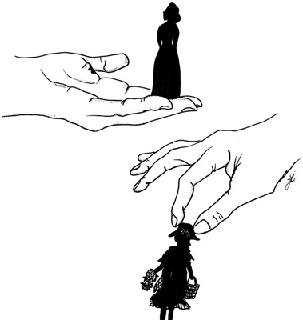

Divadelné predstavenie
8.11.2018. o 12.00.
Triedy:
III.A, III.B, III.D,
IV.B, IV.C, IV.D,
Septima B,
Oktáva A
Cena vstupeniek je 7,00 €

